Software Requirements Specification
Mouseville
Version 1.0

Prepared by Mouseville Team

April 18, 2014

Table of Contents
Table of Contents......................................................................................................................... ii
Revision History........................................................................................................................... ii
1.0 Introduction......................................................................................................................... 1
1.1 Purpose................................................................................................................................ 1
1.2 Project Scope and Product Features.................................................................................... 1
1.3 References........................................................................................................................... 1
1.4 Product Perspective............................................................................................................. 1
1.5 User Classes and Characteristics........................................................................................ 3
1.6 Operating Environment....................................................................................................... 4
1.7 Design and Implementation Constraints............................................................................. 4
1.8 User Documentation........................................................................................................... 4
2.0 System Features.................................................................................................................. 4
2.1 User Registration................................................................................................................ 4
3. External Interface Requirements......................................................................................... 6
3.1 User Interfaces.................................................................................................................... 6
3.2 Hardware Interfaces............................................................................................................ 6
3.3 Software Interfaces............................................................................................................. 6
3.4 Communications Interfaces................................................................................................ 6
4.0 Other Nonfunctional Requirements.................................................................................... 6
5.0 Behavioral Diagrams and Business Object Descriptions.....................................................7

Revision History
Name | Date | Reason For Changes | Version
Mouseville Team | 2/08/14 | Initial Draft | 1.0 draft 1
Mouseville Team | 4/18/14 | System Update | 1.1 draft 1

1. Introduction

1.1 Purpose
This SRS describes the software functional and nonfunctional requirements for release 1.0 of Mouseville. This document is intended for the members of the project team that will implement and verify the correct functioning of the system. Unless otherwise noted, all requirements specified here are high priorities and committed for release 1.0.

1.2 Project Scope and Product Features
The Mouseville application will support different aspects of data collection as it pertains to breast cancer research. A detailed project description is available in the Vision Scope Document[1]. The section in that document titled, “Scope” overviews the features that are scheduled for full implementation in this release.

1.3 References
1. Final Vision Scope Document

1.4 Product Perspective
The Mouseville application will support data collection for breast cancer research, including data input, viewing, searching, and exporting. Services such as exporting and search are implemented through the native email app and SQLite respectively.

1.5 User Classes and Characteristics

Team Leader | The team leader leads a team of Developers. He assigns what work will be done by each developer and makes sure that the work done corresponds with the overarching goal of the project objective.
Developer | Developers are the ones primarily responsible for the development of the application. Operating on an Agile development schedule, these team members will complete their assigned tasks in the time allotted.
User | The user will be the customers of the app—most likely breast cancer researchers who are looking for an improved way to record data on the mice. The app will allow them to save valuable time, and spend more time on real research.

1.6 Operating Environment
OE-1: The Mouseville application development will take place within an Apple exclusive program called XCode (version 5).
OE-2: XCode will be run on the iOS environment, specifically the Maverick operating system.
OE-3: Database will be based off CoreData with a SQLite wrapper

1.7 Design and Implementation Constraints
CO-1: The system shall use the current corporate standard SQLite database engine.
CO-2: The system shall use Cocoa Touch as the application framework with Objective-C as the programming language.
CO-3: All Objective-C code will conform to Apple standards

1.8 User Documentation
UD-1: The application requires no user documentation, as it’s been designed around a specific kind of user to be extremely intuitive and easy to use.

2. System Features

2.1 Functional Requirements
Req. # | Req. Statement | Description | Priority
R1.1 | User registration | Given that a user has downloaded the application, then the user should be able to register through the application. The user must provide user-name and e-mail address. The user can choose to provide a regularly used phone number. | High
R1.2 | Create a New Rack Space | Real-time preview of the cage rack as a grid of rack icons. As rows and columns are updated, the grid is updated to demonstrate the expected size for each cage on the rack open screen.  Valid row values are in the range of 1-10.  Valid column values are in the range of 1-7. | High
R1.3 | Edit Rack | A rack’s information should be editable. | High
R1.4 | Rack: Assign Labels | There should be a way to apply labels to the cages. These label help identify particular cage. Some examples are:  1. Gender Color Bar - Blue hue indicates male / Pink hue indicates female. If mixed sexes are in the cage, the color bar will be split into equal halves to display both male and female hues.  2. Label Color Bar - Displays all hues for assigned cage labels. Just as for the gender color bar, if all 6 color labels are applied the bar will be split into 6 equal parts and each color will be displayed. | High
R1.5 | Rack - Settings : Edit Label Names | The label names and colors can be customized per user. Also, the number of labels can increase or decrease based on user’s need. | High
R1.6 | Delete a Rack | All the mice in a rack can be marked as deceased and then the rack can be deleted. | High
R1.7 | Create a New Mouse | Enter the information of new mouse such as Gender, Genotype, Date of Birth, Rack number, Cage number, names of parents (if known). | High
R1.8 | Name a Mouse | The mouse name should be system generated, based on the cage and rack information. This name should be unique to each mouse and there should not be name conflicts between the historical information and current information. | High
R1.9 | Edit Mouse Details | Mouse information can be edited. This will basically allow updating the genotype or parents, as this information may not be available when the mouse is created in the application. Also a mouse can be marked as deceased. | High
R1.10 | Edit Cage Type | There should be a way to mark a cage as a breeding cage/ non-breeding cage. The non-breeding cage can be all-males/all-females. The cage icon should display this information. Also, there should be a way to denote an empty cage. | High
R1.11 | Move Mouse | Intuitive way of moving a mouse from one cage to another cage in the same rack or in a different rack. The name of the mouse should not change. | High
R1.12 | Search Rack | Search for a rack based on keyword. Result should be a grid of rack icons. | High
R1.13 | Search Mouse | Search for a mouse based on keyword. Search result should enlist all mice satisfying the search criteria sorted in terms of rack numbers. | High
R1.14 | Filtering Search | Allow filtering the search results based upon mouse gender.  Allow filtering the search results based upon mouse genotype.  Allow for the filtering of mouse age range. Slide is in increments of 1 week with a range of 0 - 36 weeks. | High
R1.15 | Export Mouse Data | Press the export button to export this rack or all racks to a CSV format document via email, the email address should be automatically fetched from user registration information. Alternatively, the email address can be entered after choosing to export. | High

3. External Interface Requirements

3.1 User Interfaces
UI-1: Mouseville will be developed according to the sponsor’s idea of the application. The app will be as intuitive as possible without cutting important functionality.

3.2 Hardware Interfaces
No hardware interfaces have been identified.

3.3 Software Interfaces
SI-1: User Registration System
SI-2: Add genotype
SI-3: Add rack
SI-4: Search function
SI-5: Change label
SI-6: Edit cage details
SI-7: Add mouse
SI-8: Edit mouse
SI-9: Move mouse

3.4 Communications Interfaces
CI-1: Mouseville’s export to CSV functionality utilizes the iPad’s native email app to send an attached CSV file to the user’s desired destination.

4. Other Nonfunctional Requirements
The requirements in this section provide a detailed specification of the software system classified into non-functional pertaining to user interaction and measurements placed on the system.

    - Performance Requirements:
- As the application is targeted towards a mobile architecture, overall performance of the application plays a crucial role.
- The loading of the user screens should take place in an even and well-timed manner. All the pop-ups, obtrusive or non-obtrusive should not force the user wait for than the acceptable time.
- The search function (for mice) should return results as quickly as possible without forcing the user to wait for an indefinite time.
- The exporting of CSV file (via email) should display proper message and logo to enable the user to understand that a resource intensive task is being performed and the application should not give an impression of being in a non-responsive state.

    - Reliability Requirements:
- The backend database store of the application must be always in a consistent state.
- Various states of application execution i.e. running, send to background, brought to foreground, force kill, which are have a high probability of translation within a mobile application must be properly handled.
- The export of CSV file (via email) should be highly reliable and only in an event of a blocking firewall and no network connectivity should the export be halted. Proper message should be displayed to user in this case.
- Format of the CSV file should match the format present with the client for easy integration of data.
- The application should not crash in absence or error in handling user input and in case of non-availability of the backend database.

    - Availability Requirements:
- The application being on a mobile system, it should be available as and when the device is running.
- The application should have sufficient storage available for the backend database.
- The backend database store must be available for the application for processing when the application is running.
- Proper internet connectivity must be available for the export of CSV file (via email).

    - Security Requirements:
- The backend database store of the application must be prevented from accidental delete.
- The current state of the application on the mobile system does not call for any security measures.
- This requirement will be updated as and when major security measures are required and implemented.

    - Maintainability Requirements:
- The application modules must be loosely coupled and monolithic design for components should be highly avoided.
- Third party libraries, apart from the native platform, if involved, must be properly documented for their usage.
- The Mean Time To Repair (MTTR) should ideally not exceed beyond two weeks.

    - Software Quality Requirements:
- The look and feel of the application should be pleasant, consistent and according to standard guideline of the native platform.
- The naming and editing of resources (mice) must be according to requirement of the client.
- The application should be intuitive, engaging and easy to handle for non-technical users.

    - Portability Requirements:
- The application should be instable on the devices falling under the specification of application environment.
- The application should ideally be able to run on newer versions of the platform with minimal change.

- Behavioral Diagrams and Business Object Descriptions 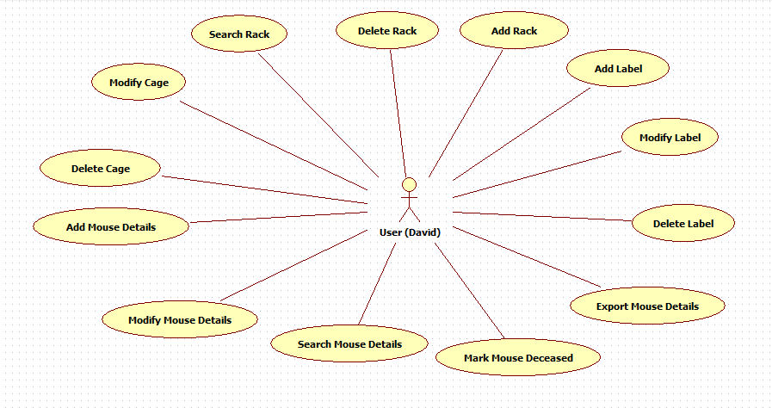
Described above is the Use-case diagram for this project. We have a single user – David and multiple use cases.
- Use case 1: Add Rack
User will be able to add racks by dimensions like 7 rows and 11 columns. The rack will be created accordingly. For this case 77 cages will be automatically created after this rack is created.
- Use case 2: Delete Rack
User will be able to delete racks after selecting it and pressing on delete.
- Use Case 3: Modify Cage
User will be able to modify cage details like enter some text for that cage.
- Use Case 4: Delete Cage
This will simply mark the cage as empty. The cage will not be physically deleted until the rack is deleted.
- Use Case 5: Add Mouse Details
User will be able to add mouse details by gender, genotype in a cage. He can also add parents for the mouse.
- Use Case 6: Modify Mouse Details
User will be able to change mouse name, gender, genotype, parent etc.
- Use Case 7: Delete Mouse Details
User will be able to delete mouse details (i.e. mark a mouse as deceased).
- Use Case 8: Export Mouse Details
User can export all mouse details in .csv format in mail configured with the application.
- Use Case 9: Add Label
User can add different types of labels to each cage like for genotype, etc.
- Use case 10: Edit Label
User can modify these labels to accommodate new research findings like if the user does not want to label by genotype but something similar, he can modify the label accordingly.
- Use case 11: Delete Label
User can delete these labels if he no longer needs them.
- Use Case 12: Search Racks
As soon as user logs in the system, he can search racks by name. By Default all racks will be visible.
- Use case 13: Search Mouse Details
When user clicks on Mice tab, by default all mice details will be visible to the user. Also consolidated search options are provided for retrieving more refined mice details.

